Ex. No. 9 | Update Information in Google Firestore Database
Date of Exercise | 01-11-2025

Github Code Link

Video Link

Aim:
To develop a Flutter application that update information from Google Firestore Database based on user input and displays the updated information on the screen.
Description:
- Google Cloud Firestore is a NoSQL cloud database service provided by Google as part of the Firebase platform, designed to handle scalable and real-time data access for mobile and web applications.
- The products collection is pre-filled manually using the Firebase Console. Each document in this collection contains the fields:
Name (String), Quantity (Number), Price (Number)
- The Firestore update() function is used to modify specific fields of an existing document without overwriting the entire document.
Syntax:
FirebaseFirestore.instance
.collection('products')
.doc(docId)
.update({'fieldName': newValue});
Integration of Google Firestore in Flutter
- Install Android Studio and create an Android Virtual Device (AVD) or connect a real device for testing.
- Create a Flutter project in VS Code or Android Studio.
- Create or use an existing Firebase project in the Firebase Console.
- Add the Flutter app to Firebase, download the google-services.json file, and place it inside the android/app/ directory.
- Enable Cloud Firestore from Build → Firestore Database → Create Database in Firebase Console.
Gradle Configuration
- Project-Level build.gradle
buildscript {
repositories {
google()
mavenCentral()
}
dependencies {
classpath("com.google.gms:google-services:4.4.1")
}
}
- App-Level build.gradle
plugins {
id("com.google.gms.google-services")
}
android {
ndkVersion = "27.0.12077973"
}
defaultConfig {
minSdk = 23
}
dependencies {
implementation(platform("com.google.firebase:firebase-bom:34.3.0"))
}
- Pubspec Dependencies
dependencies:
flutter:
sdk: flutter
firebase_core: ^3.4.0
cloud_firestore: ^5.4.4

Question:
Title: Update Product Details using Google Firestore
Scenario: Assume that the products collection is already pre-filled manually in Google Firestore (using Firebase Console). Each document contains:
- name (String)
- quantity (Number)
- price (Number)
Task Requirements:
- Do NOT add any new product using Flutter. Products are already stored manually in Firestore.
- On the Flutter screen:
- Provide a TextField to enter product name
- Provide TextFields for new quantity and new price
- A “Search” button
- An “Update” button
- Search Functionality:
- When the user enters a product name and clicks Search:
- Fetch that product from Firestore
- Display its name, quantity, and price on the screen
- Update Functionality:
- User can modify the quantity and price fields
- On clicking Update, the app should update the Firestore document
- Display the updated product details immediately

Program:
Main.dart
import 'package:flutter/material.dart';
import 'package:firebase_core/firebase_core.dart';
import 'package:cloud_firestore/cloud_firestore.dart';
void main() async {
WidgetsFlutterBinding.ensureInitialized();
await Firebase.initializeApp();
runApp(const MaterialApp(
debugShowCheckedModeBanner: false,
home: UpdateProductScreen(),
));
}
class UpdateProductScreen extends StatefulWidget {
const UpdateProductScreen({super.key});
@override
State<UpdateProductScreen> createState() => _UpdateProductScreenState();
}
class _UpdateProductScreenState extends State<UpdateProductScreen> {
final TextEditingController _nameController = TextEditingController();
final TextEditingController _quantityController = TextEditingController();
final TextEditingController _priceController = TextEditingController();
String _statusMessage = "";
String? _docId;
Future<void> _searchProduct() async {
final name = _nameController.text.trim();
if (name.isEmpty) {
setState(() {
_statusMessage = "Please enter a product name.";
_docId = null;
});
return;
}
final querySnapshot = await FirebaseFirestore.instance
.collection('products')
.where('name', isEqualTo: name)
.get();
if (querySnapshot.docs.isEmpty) {
setState(() {
_statusMessage = "Product not found.";
_docId = null;
_quantityController.clear();
_priceController.clear();
});
} else {
final product = querySnapshot.docs.first;
setState(() {
_docId = product.id;
_quantityController.text = product['quantity'].toString();
_priceController.text = product['price'].toString();
_statusMessage = "Product loaded successfully.";
});
}
}
Future<void> _updateProduct() async {
if (_docId == null) {
setState(() {
_statusMessage = "Please search a product first.";
});
return;
}
final newQuantity = int.tryParse(_quantityController.text.trim());
final newPrice = double.tryParse(_priceController.text.trim());

if (newQuantity == null || newPrice == null) {
setState(() {
_statusMessage = "Please enter valid quantity and price.";
});
return;
}

await FirebaseFirestore.instance
.collection('products')
.doc(_docId)
.update({
'quantity': newQuantity,
'price': newPrice,
});

setState(() {
_statusMessage = "Product updated successfully!";
});
}

@override
Widget build(BuildContext context) {
return Scaffold(
appBar: AppBar(
title: const Text("Update Product Details"),
backgroundColor: const Color.fromARGB(255, 187, 0, 78),
),
body: Padding(
padding: const EdgeInsets.all(20),
child: SingleChildScrollView(
child: Column(
children: [
TextField(
controller: _nameController,
decoration: const InputDecoration(
labelText: "Enter product name",
border: OutlineInputBorder(),
),
),
const SizedBox(height: 10),
ElevatedButton(
onPressed: _searchProduct,
child: const Text("Search"),
),
const SizedBox(height: 20),
TextField(
controller: _quantityController,
keyboardType: TextInputType.number,
decoration: const InputDecoration(
labelText: "Quantity",
border: OutlineInputBorder(),
),
),
const SizedBox(height: 10),
TextField(
controller: _priceController,
keyboardType: TextInputType.number,
decoration: const InputDecoration(
labelText: "Price (₹)",
border: OutlineInputBorder(),
),
),
const SizedBox(height: 10),
ElevatedButton(
onPressed: _updateProduct,
style: ElevatedButton.styleFrom(backgroundColor: Colors.green),
child: const Text("Update"),
),
const SizedBox(height: 20),
Text(
_statusMessage,
style: TextStyle(
color: _statusMessage.contains("not") ||
_statusMessage.contains("Please")
? Colors.red
: Colors.green,
fontSize: 16),
),
],
),
),
),
);
}
}

Output Screenshot:
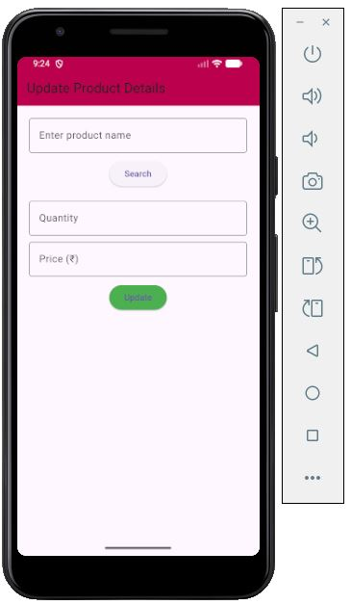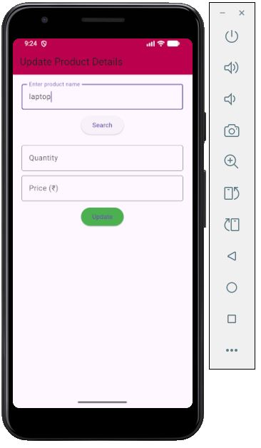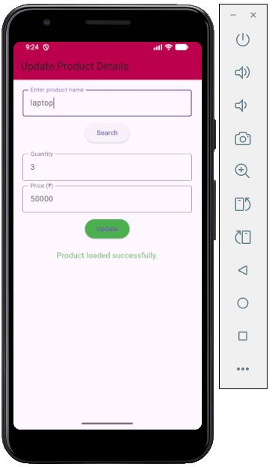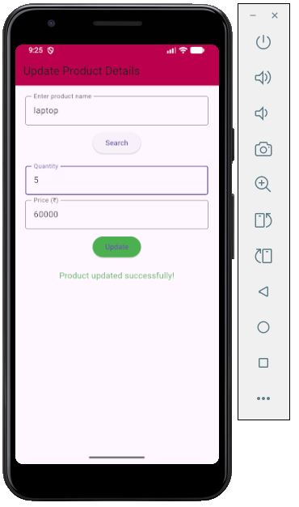

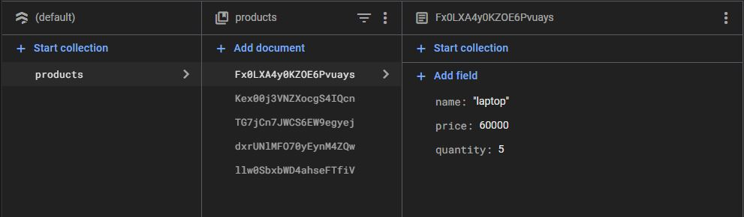

Result:
Thus successfully developed a Flutter application that update information from Google Firestore Database based on user input and displays the updated information on the screen.

